**Django setup:**

Make project name folder

go inside it

create venv activate venv

pip install Django

Django-admin startproject name .

Py manage.py runserver

Py manage.py runserver 4000 (port)

Py manage.py startapp name

Vscode extension sqllite 3 editor

**Django views:**

Sending data to home_page view from url.

Path('home/',views.home_page,{"status":True}).

Def home_page(req,**kwargs):

kwargs[“status”]

dic_name={data} .

For using templates we use

Render(req,’ template_name’ e.g. (‘app_name/.html ,context=dic_name).

Inside .html file we simply use keys of dic as variables and render it.

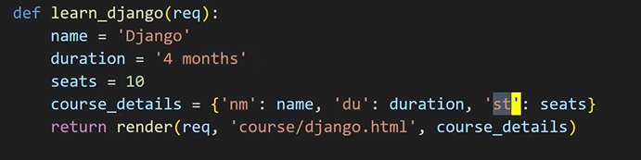

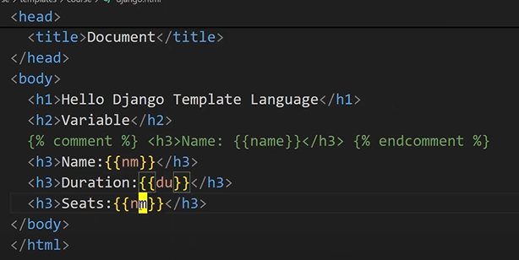

**Django Templates:**

We make a templates folder inside the app of project

Inside that templates folder make a new folder of same name as app name

Inside that folder create .html files

We can also change the location of that template folder by giving path in setting.py templates list.

For using templates make sure app in in installed app lists in setting.py

**Django Templates Language:**

**Filters:**

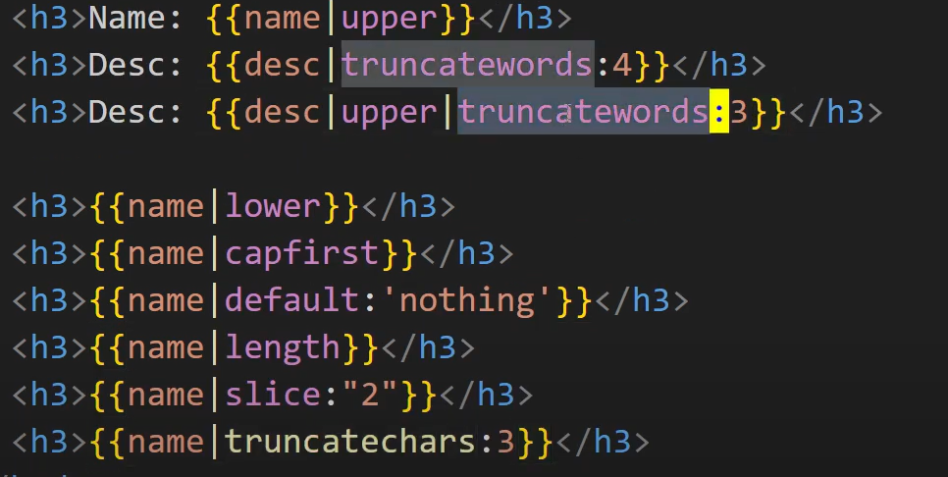

**For date and time:**

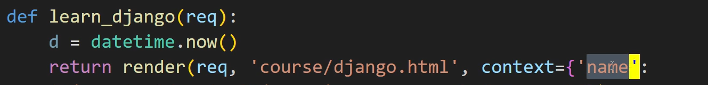

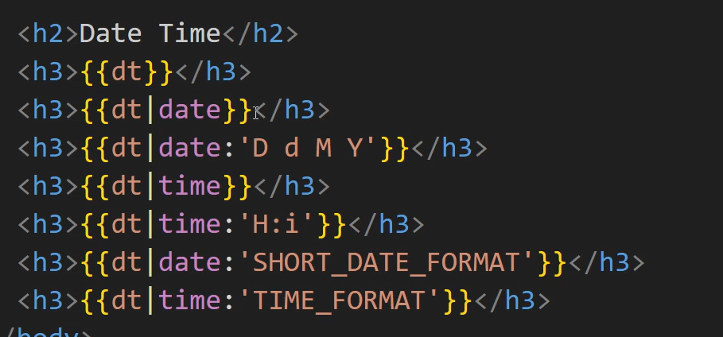

**For Floating numbers:**

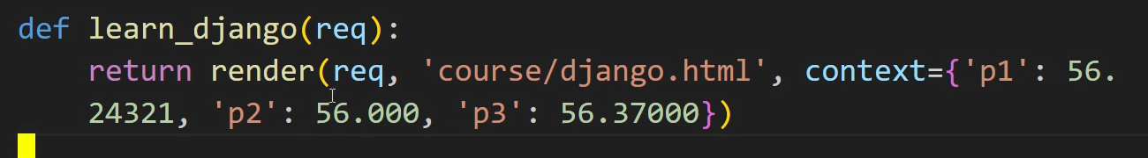

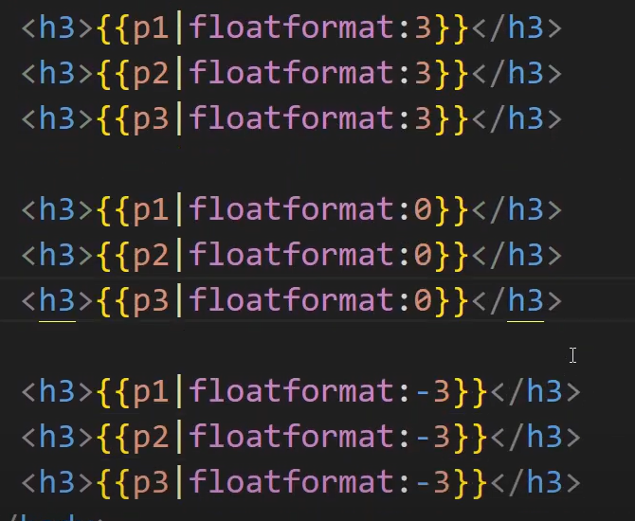

**If else:**

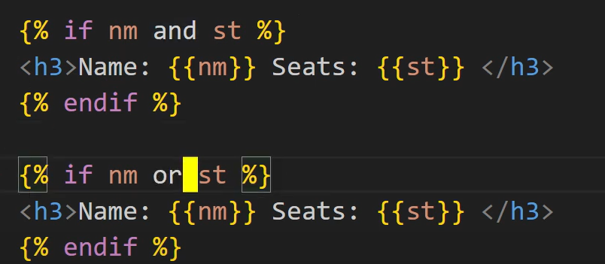

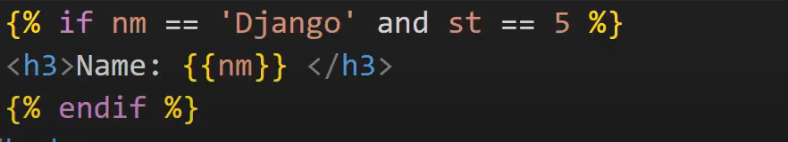

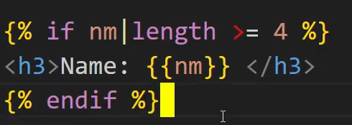

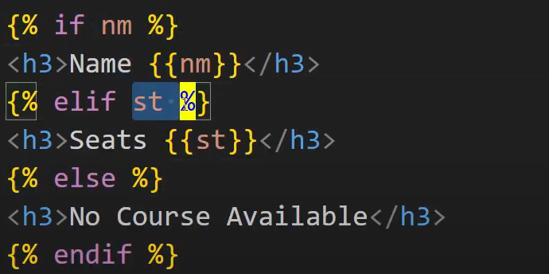

**For for loop:**

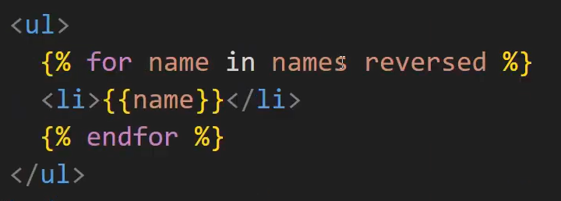

**For dictionary:**

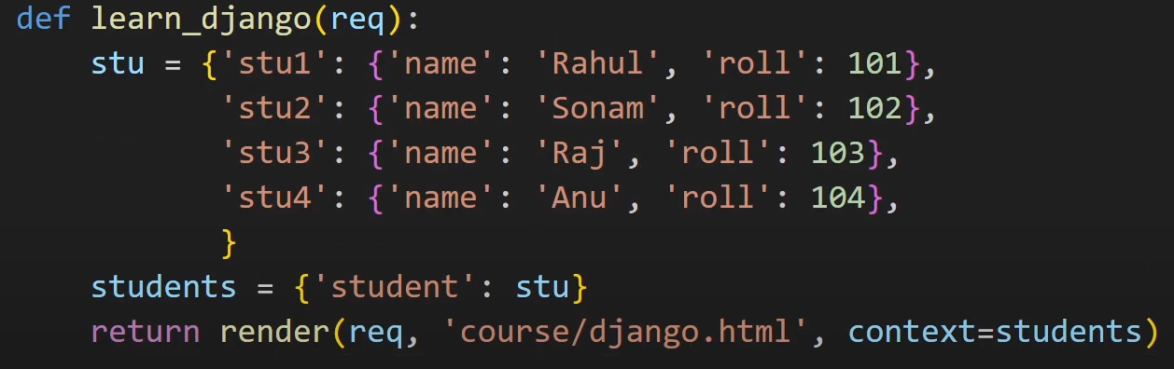

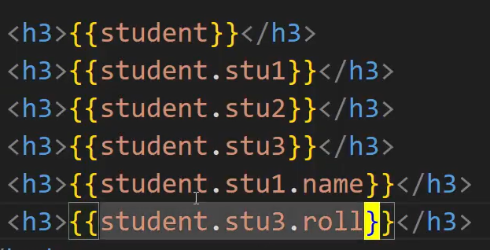

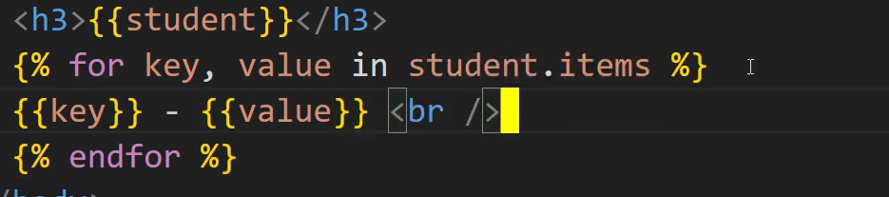

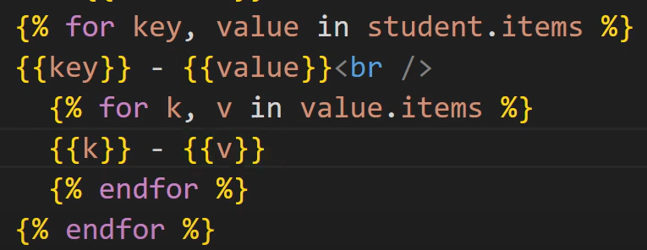

**Truncatewrods example:**

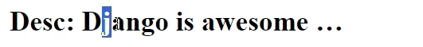

**Django Static Files:**

**For css**

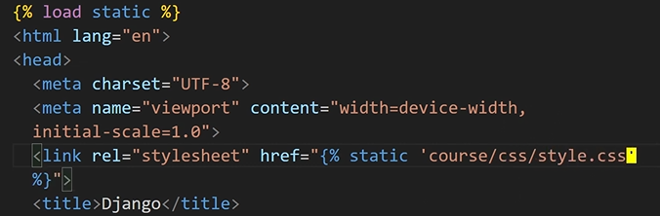

**For js**



**For images**



**Django Template Inheritance:**

In **Django**, **template inheritance** is a way to avoid repeating the same HTML structure (like headers, navigation bars, or footers) across multiple pages of your website. Instead of duplicating code in every HTML file, you define a **base template** with common elements and then create **child templates** that extend this base and fill in or override specific sections.

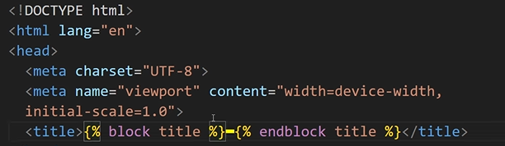

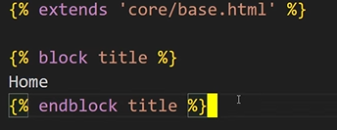

In child the order of blocks should be same as in base.html you define.

**Django Static Files Inheritance:**

In base.html we define like this

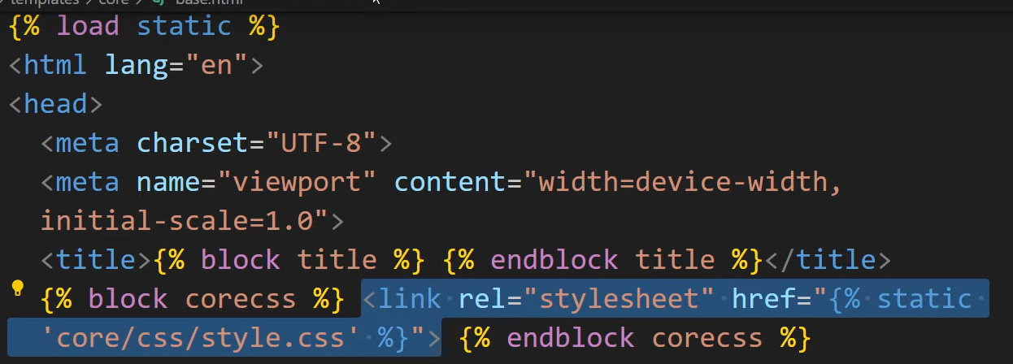

In child we use different css + use patent css

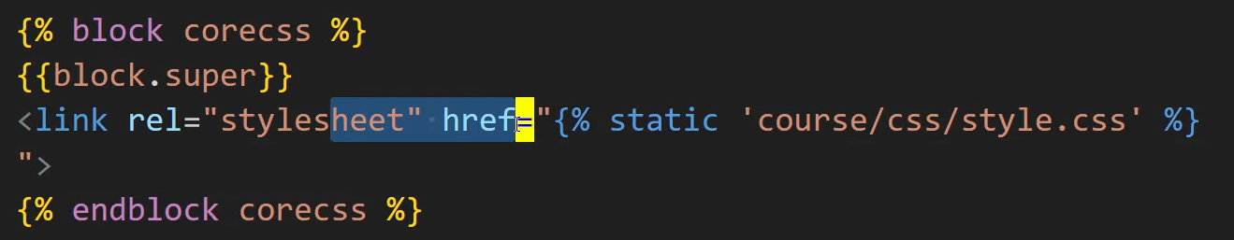

**Django Hyper Link:**

We use /home we need to give url from base like 8000/home and if we need to to extend then we give home/ like 8000/home/home/ in herf html.

**Django include:**

we have include, which is used to reuse small pieces of template code (like a navbar, sidebar, or a reusable form snippet) inside other templates. We can also use variables in include templates.

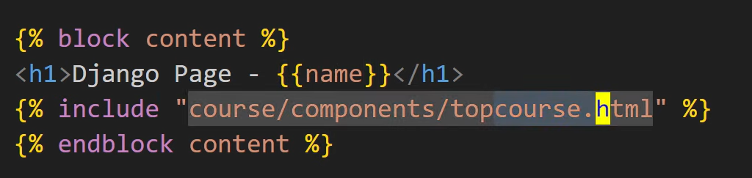

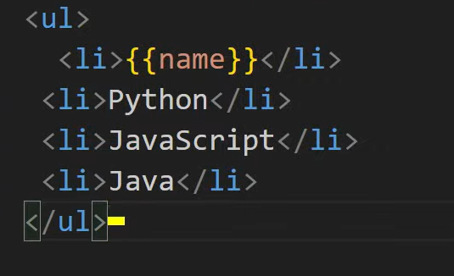

**Django Form:**

In Django, forms are a way to handle user input (like login, registration, feedback, etc.). Django makes forms easy by:

1. Rendering HTML form fields automatically.
2. Validating user input.
3. Converting input data into Python types.
4. Saving data directly into the database (if linked to a model).

Types of Forms in Django

1. forms.Form (Normal Form)  
   → Use when you want a form not directly connected to a model.
2. forms.ModelForm (Model-based Form)  
   → Use when you want a form linked to a model (so data can be saved directly).

For making Django forms we make a file in app of names forms.py and inside it we make a class like in model that extends forms.Form other things are same like models.

Like models we also import from class in views and call that class and send it to the template.

**Django form render manually:**

When we call form in view we give an argument auto_id=True, False

In template we use like

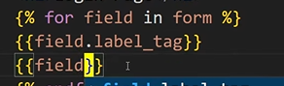

Here we can get form fields and labels from id and apply css.

**Django form Post req:**

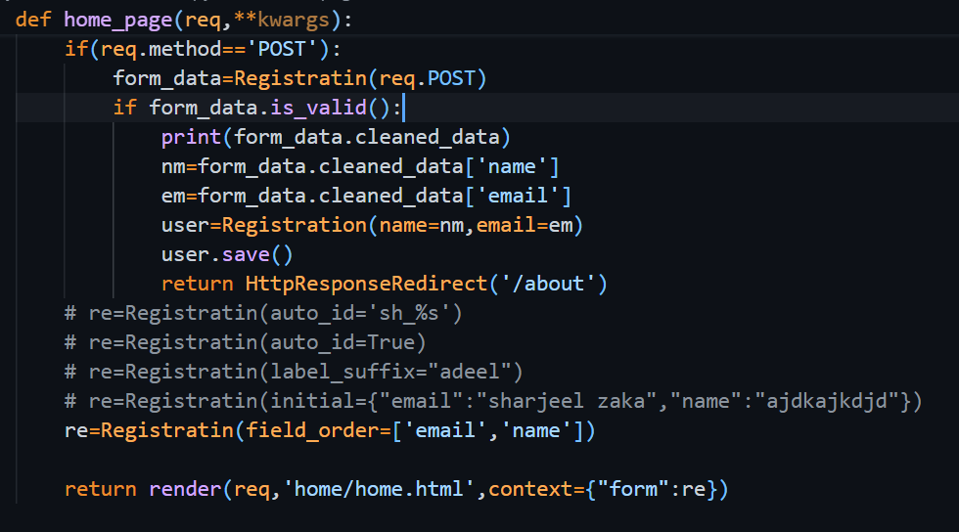

**Django Model form:**

A ModelForm is a Django form that is directly tied to a model.

* It automatically generates form fields from the model fields.
* It can save data directly to the database using .save().
* It reduces repetitive code.

**class Registration(forms.ModelForm):**

confirm_password = forms.CharField()

This form is tied to the Login model.

It has an extra field confirm_password that is not in the model, but added only for form validation (e.g., password confirmation).

**Meta Class (Form Configuration)**

class Meta:

model = Login

fields = ['email']

fields = '__add__' # ❌ (typo, should be '__all__' if you want all fields)

exclude = ['name'] # Excludes 'name' field from the form

* model → which model this form is linked to (Login).
* fields → which model fields to include (email).
* exclude → fields to exclude (name).

⚠️ Note: You cannot use both fields and exclude together. Use one of them.  
⚠️ fields='__add__' is invalid → should be fields='__all__' if you want all fields.

**Customization**

labels = {

'Email': "Enter Email"

}

* Changes the label of the email field to "Enter Email".  
  ⚠️ Note: The key should match the model field name ('email' not 'Email').

error_messages = {

'email': {

'required': 'Email is required.'

}

}

* Overrides the default error message when email is left empty.

widgets = {

'email': forms.PasswordInput()

}

* Changes how the field is rendered → email will show as a password input (hidden characters).

**StudentForm (Child Form)**

class StudentForm(Registration):

class Meta(Registration.Meta):

labels = ['name']

* **Inheritance**: StudentForm extends Registration → it reuses its configuration.
* Meta is subclassed → but here labels = ['name'] is invalid. It should be a **dict**, not a list. Example:

labels = {'name': 'Enter Name'}

**Django form fields:**

forms.CharField(),.EmailField,.IntegerField,.FloatField,.DateField,.TimeField,.DateTimeField,BolleanField,.NullBulleanField,.ChoiceField(choices=[(‘F’,’Female’),(‘M’,’Male’),(‘O’,’Other’)]),.MultipleChoiceField(choices=[(‘tech’,’Technology’),(‘art’,’Art’),(‘sports’,’Sports’)]),.ImageField,.FileField,.URLField,.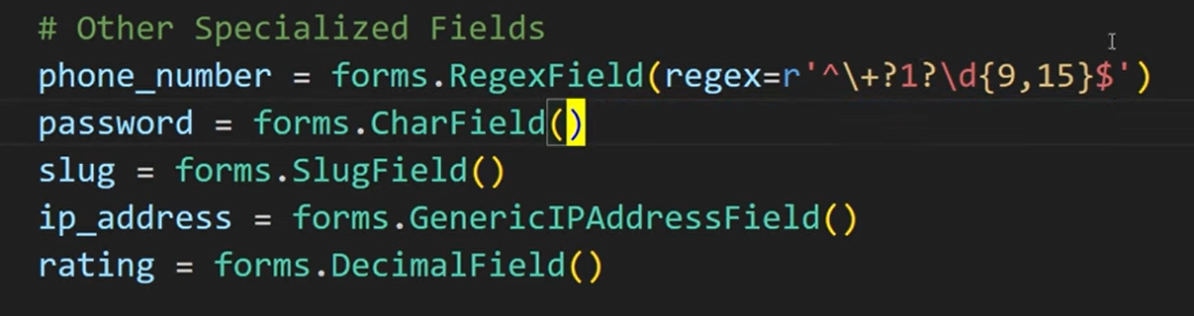

**Django from arguments and widgets:**

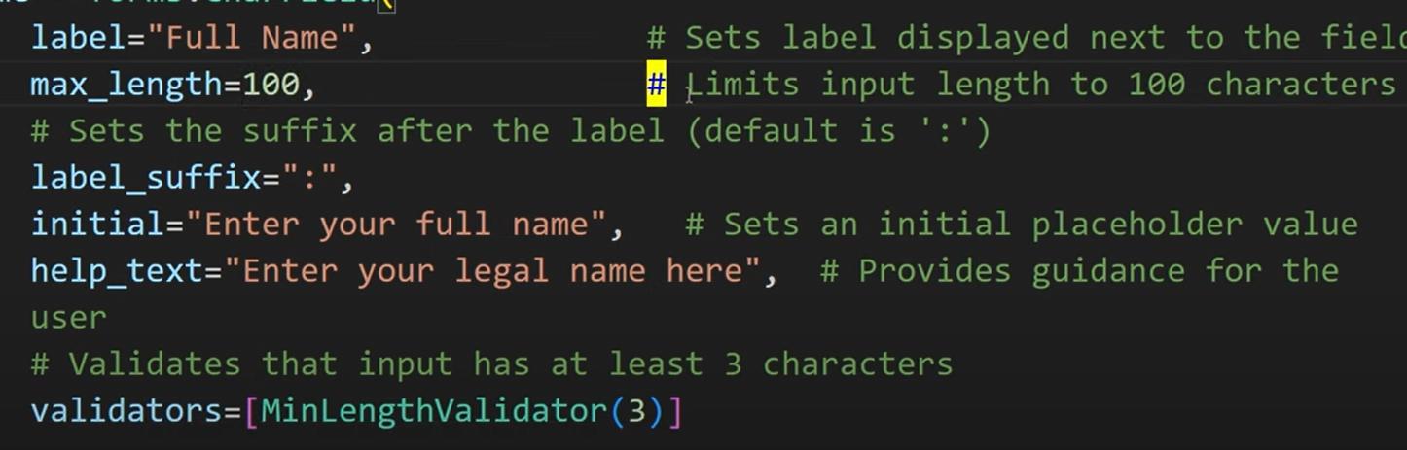

disable=True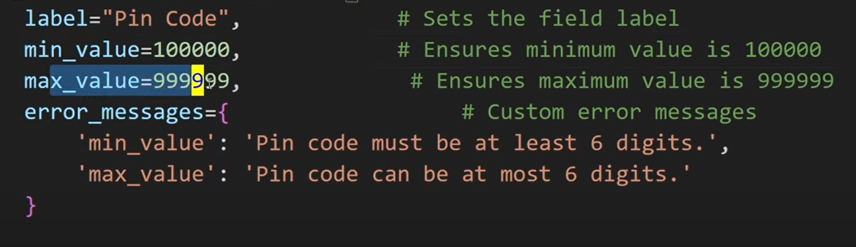

required=False

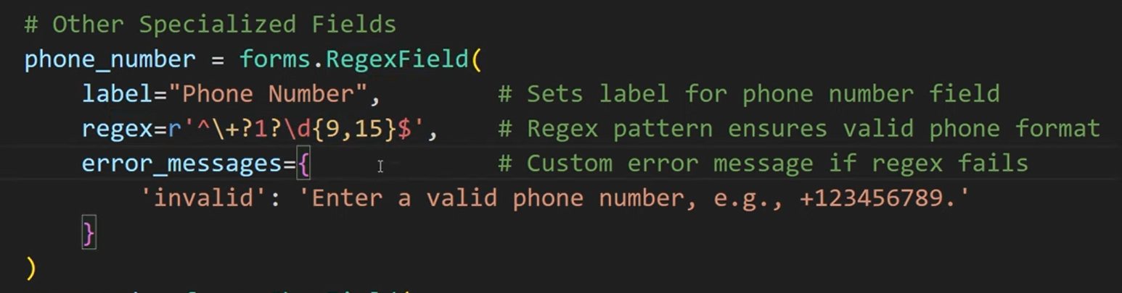

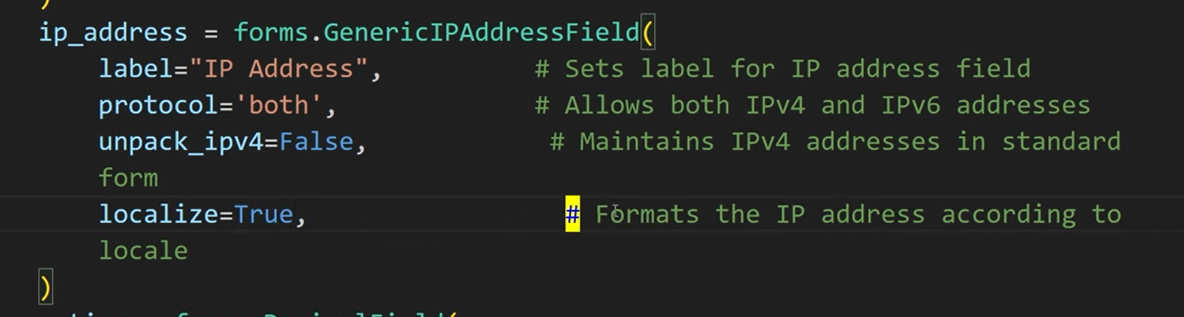

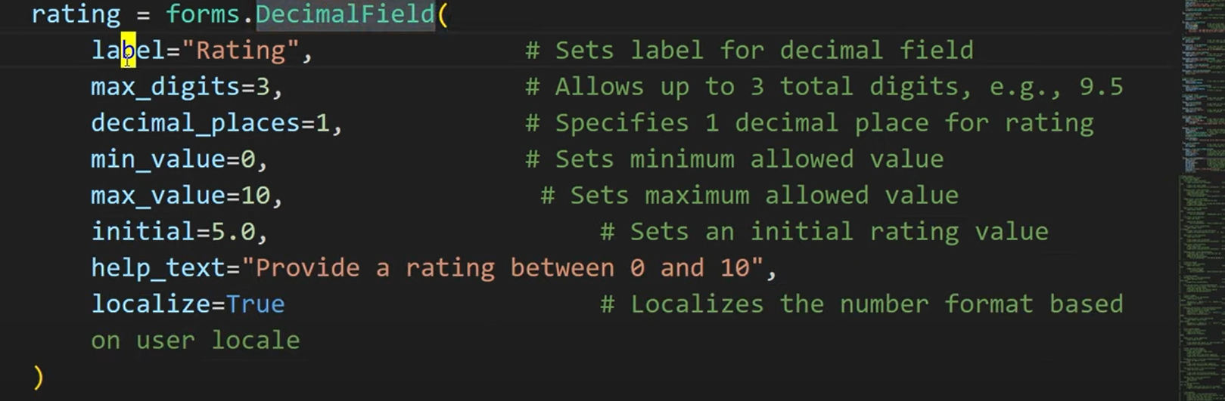



**Django form validator:**

**Built in validator:**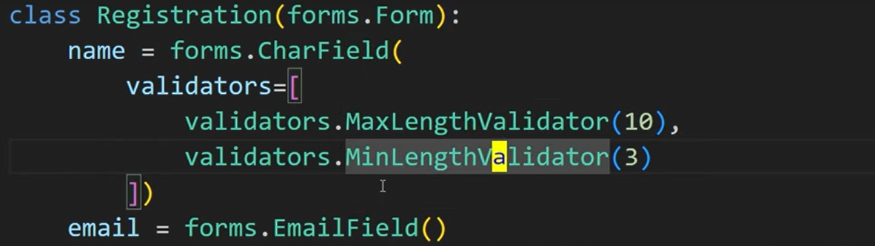

**Custom validator:**

**Function of validtor**

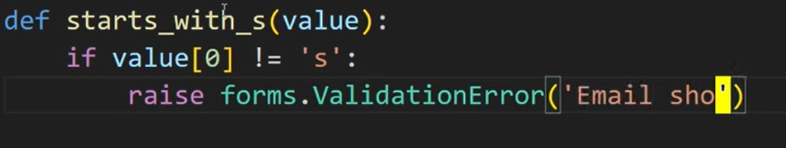

In foms model we do like this.



**Forms errors:**

We can get the class of error {{field.errors}}

And apply css on this div

**Django Models:**

to see sql query a model class generate.****

**Django model admin register:**

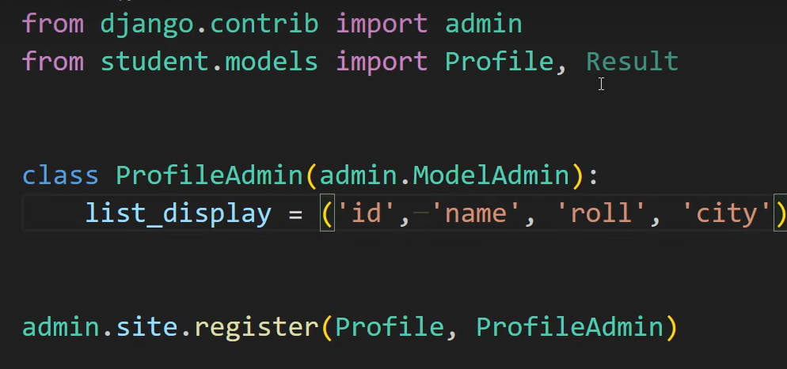

This helps me to see table content on admin panel.

**Django querystr:**

In **Django**, a **QuerySet** is simply a **collection of database queries** that represent a set of objects (rows) from your database.

We can directly send data to template without cleaning it.

ModelName.object.all(),.filter(attrbname=70),.exclude(attrab),.order_by(attrab),.values(attarb),.get(pk=1),.first(),.order_by(attrb).first(),.last(),.latest(‘pass_date’),.earliest(‘pass_date’),.create(attrbs),.filter(attrb).update(attrab),.

**Django Filed loopkup:**

.filter(name_exact=’sharjeel’),.filter(name_iexact=’sharjeel’),id_in=[1,3,5],markes_gte=200,lte,name_startswith=’S’,isStartswith=’s’,endswith=’r’,iendwith=’s’,

**Django aggregate:**

From [django.db](http://django.db).models import Avg,Sum,Min,Max,Count

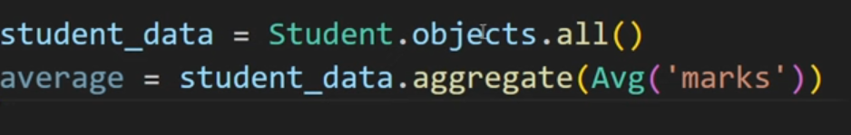

**Django Q object:**

Used when we need to write complex queries.

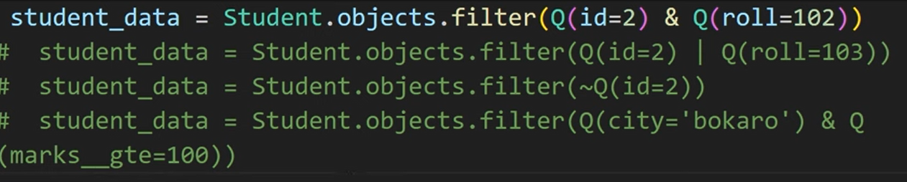

**Django model limit:**



.all()[start:end:gap]

**Django model inharitence:**

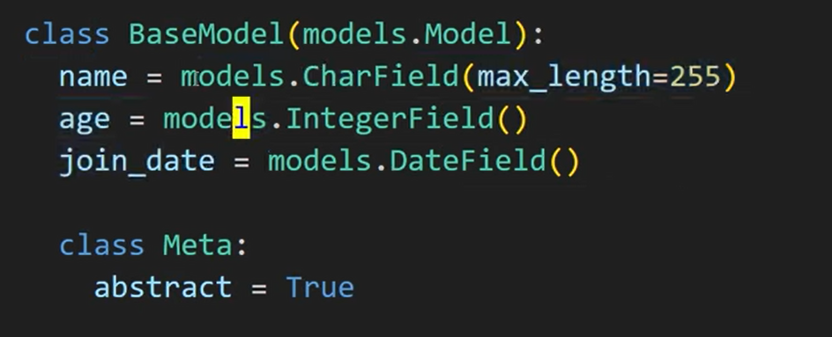

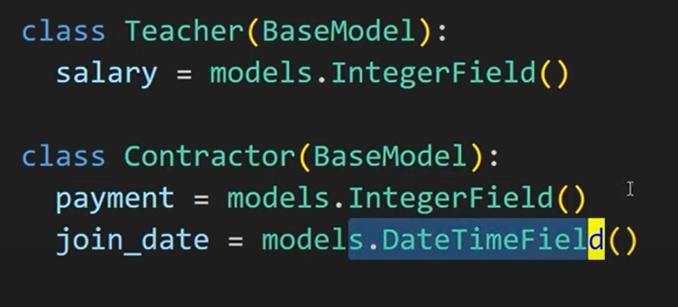

**Django multi table inheritance:**

It create a one to one relationship between tables so in child table it is one to one relationship.

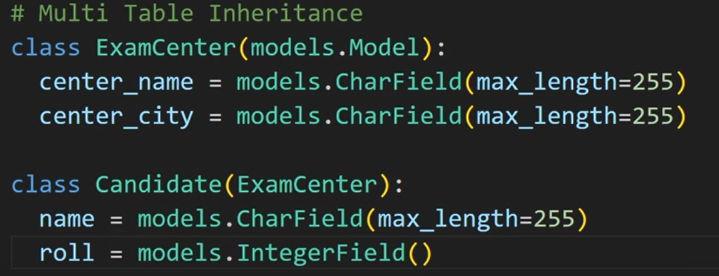

**Django one-to-one relationship:**

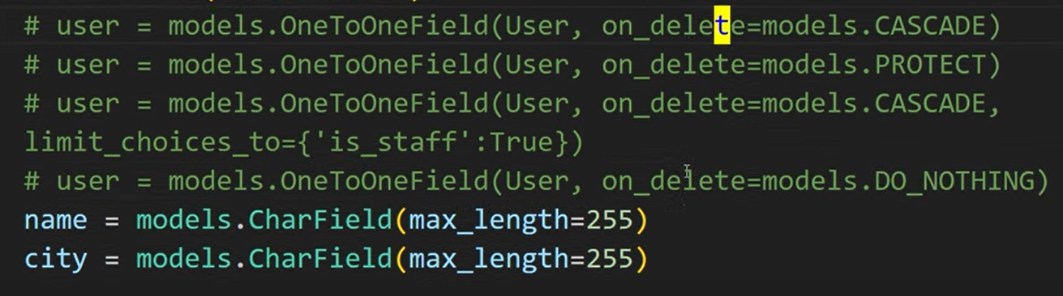

**Django one-to-many:**

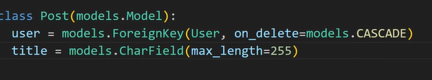

**Django many-to-many:**

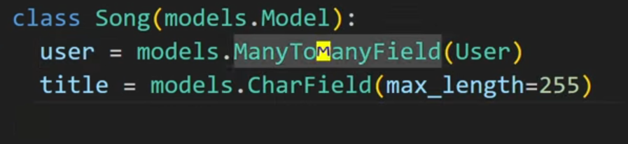

**Django Success and Error messages:**



